UNIT 6 - SOFTWARE QUALITY ASSURANCE AND SECURITY

Software Quality Definition:
Software Quality is defined as the conformance to explicitly state functional and performance requirements, explicitly documented development standards, and inherent characteristics that are expected of all professionally developed software.

Software Quality is conformance to:
explicitly stated functional and performance requirements,
explicitly documented development standards,
implicit characteristics that are expected of all professionally developed
software.
Quality defines to any measurable characteristics such as correctness, maintainability, portability, testability, usability, reliability, efficiency, integrity, reusability, and interoperability.

Quality Control: Quality Control involves a series of inspections, reviews, and tests used throughout the software process to ensure each work product meets the requirements place upon it. Quality control includes a feedback loop to the process that created the work product.
Quality Assurance: Quality Assurance is the preventive set of activities that provide greater confidence that the project will be completed successfully.
Quality Assurance focuses on how the engineering and management activity will be done?
As anyone is interested in the quality of the final product, it should be assured that we are building the right product.
It can be assured only when we do inspection & review of intermediate products, if there are any bugs, then it is debugged. This quality can be enhanced.

Importance of Quality
We would expect the quality to be a concern of all producers of goods and services. However, the distinctive characteristics of software and in particular its intangibility and complexity, make special demands.
Increasing criticality of software: The final customer or user is naturally concerned about the general quality of software, especially its reliability. This is increasing in the case as organizations become more dependent on their computer systems and software is used more and more in safety-critical areas. For example, to control aircraft.
The intangibility of software: This makes it challenging to know that a particular task in a project has been completed satisfactorily. The results of these tasks can be made tangible by demanding that the developers produce 'deliverables' that can be examined for quality.
Accumulating errors during software development: As computer system development is made up of several steps where the output from one level is input to the next, the errors in the earlier ?deliverables? will be added to those in the later stages leading to accumulated determinable effects. In general the later in a project that an error is found, the more expensive it will be to fix. In addition, because the number of errors in the system is unknown, the debugging phases of a project are particularly challenging to control.

Software Quality Assurance
Software quality assurance is a planned and systematic plan of all actions necessary to provide adequate confidence that an item or product conforms to establish technical requirements.
A set of activities designed to calculate the process by which the products are developed or manufactured.

SQA Encompasses
- A quality management approach
- Effective Software engineering technology (methods and tools)
- Formal technical reviews that are tested throughout the software process
- A multitier testing strategy
- Control of software documentation and the changes made to it.
- A procedure to ensure compliances with software development standards
- Measuring and reporting mechanisms.

SQA Activities
Software quality assurance is composed of a variety of functions associated with two different constituencies ? the software engineers who do technical work and an SQA group that has responsibility for quality assurance planning, record keeping, analysis, and reporting.

Following activities are performed by an independent SQA group:
- Prepares an SQA plan for a project: The program is developed during project planning and is reviewed by all stakeholders. The plan governs quality assurance activities performed by the software engineering team and the SQA group. The plan identifies calculation to be performed, audits and reviews to be performed, standards that apply to the project, techniques for error reporting and tracking, documents to be produced by the SQA team, and amount of feedback provided to the software project team.
- Participates in the development of the project's software process description: The software team selects a process for the work to be performed. The SQA group reviews the process description for compliance with organizational policy, internal software standards, externally imposed standards (e.g. ISO-9001), and other parts of the software project plan.
- Reviews software engineering activities to verify compliance with the defined software process: The SQA group identifies, reports, and tracks deviations from the process and verifies that corrections have been made.
- Audits designated software work products to verify compliance with those defined as a part of the software process: The SQA group reviews selected work products, identifies, documents and tracks deviations, verify that corrections have been made, and periodically reports the results of its work to the project manager.
- Ensures that deviations in software work and work products are documented and handled according to a documented procedure: Deviations may be encountered in the project method, process description, applicable standards, or technical work products.
- Records any noncompliance and reports to senior management: Non- compliance items are tracked until they are resolved.

Quality Assurance v/s Quality control
Parameters | Quality Assurance (QA) | Quality Control (QC)
Objective | It focuses on providing assurance that the quality requested will be achieved. | It focuses on fulfilling the quality requested.
Technique | It is the technique of managing quality. | It is the technique to verify quality.
Involved in which phase? | It is involved during the development phase. | It is not included during the development phase.
Program execution is included? | It does not include the execution of the program. | It always includes the execution of the program.
Type of tool | It is a managerial tool. | It is a corrective tool.
Process/ Product-oriented | It is process oriented. | It is product oriented.
Aim | The aim of quality assurance is to prevent defects. | The aim of quality control is to identify and improve the defects.
Order of execution | It is performed before Quality Control. | It is performed after the Quality Assurance activity is done.
Technique type | It is a preventive technique. | It is a corrective technique.
Measure type | It is a proactive measure. | It is a reactive measure.
SDLC/ STLC? | It is responsible for the entire software development life cycle. | It is responsible for the software testing life cycle.
Activity level | QA is a low-level activity that identifies an error and mistakes that QC cannot. | It is a high-level activity that identifies an error that QA cannot.
Focus | Pays main focus is on the intermediate process. | Its primary focus is on final products.
Team | All team members of the project are involved. | Generally, the testing team of the project is involved.
Aim | It aims to prevent defects in the system. | It aims to identify defects or bugs in the system.
Time consumption | It is a less time-consuming activity. | It is a more time-consuming activity.
Which statistical technique was applied? | Statistical Process Control (SPC) statistical technique is applied to Quality Assurance. | Statistical Quality Control (SQC) statistical technique is applied to Quality Control.
Example | Verification | Validation

Quality Assurance | Quality Control
Quality Assurance (QA) is the set of actions including facilitation, training, measurement, and analysis needed to provide adequate confidence that processes are established and continuously improved to produce products or services that conform to specifications and are fit for use. | Quality Control (QC) is described as the processes and methods used to compare product quality to requirements and applicable standards, and the actions are taken when a nonconformance is detected.
QA is an activity that establishes and calculates the processes that produce the product. If there is no process, there is no role for QA. | QC is an activity that demonstrates whether or not the product produced met standards.
QA helps establish process | QC relates to a particular product or service
QA sets up a measurement program to evaluate processes | QC verified whether particular attributes exist, or do not exist, in a explicit product or service.
QA identifies weakness in processes and improves them | QC identifies defects for the primary goals of correcting errors.
Quality Assurance is a managerial tool. | Quality Control is a corrective tool.
Verification is an example of QA. | Validation is an example of QC.

SQA Implementation in different phases
Quality assurance will be implemented through all the software life cycles of the tool’s development process, until the release of the software product. The following are the quality assurance tasks for each phase of the software development:
Requirements phase: When the SRS is being developed, the developer has to ensure that it elucidates the proposed functionality of the product and to keep refining the SRS until the requirements are clearly stated and understood.
Specification and Design phase: Due to the great importance for accuracy and completeness in these documents, weekly reviews shall be conducted between the developer and the professor to identify any defects and rectify them.
Implementation phase: The developer shall do code reviews when the construction phase of the Tool begins.
Software testing phase: The developer shall test each case. The final product shall be verified with the functionality of the software as specified in the Software Requirements Specification (SRS) for the Tool.
Through all these phases of the software development, the following shall also be conducted to improve the software quality:
- · Develop and generate SQAP: Generate a finalized SQAP plan
- · Communication and Feedback: The developer is encouraged to freely express disagreements, suggestions and opinions about all aspects of the weekly process of software development.
- · Internal audits and evaluations: The Major professor and the committee are expected to do auditions and evaluations at the end of each phase in the project.

Quality Evaluation Standards:

Six Sigma
Six Sigma is the process of improving the quality of the output by identifying and eliminating the cause of defects and reduce variability in manufacturing and business processes. The maturity of a manufacturing process can be defined by a sigma rating indicating its percentage of defect-free products it creates. A six sigma method is one in which 99.99966% of all the opportunities to produce some features of a component are statistically expected to be free of defects (3.4 defective features per million opportunities).
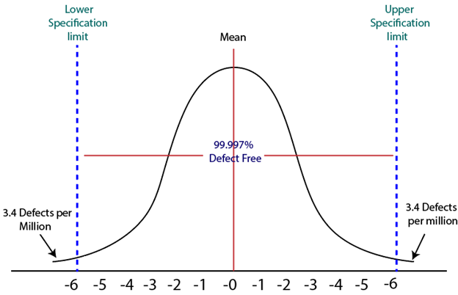

History of Six Sigma
Six-Sigma is a set of methods and tools for process improvement. It was introduced by Engineer Sir Bill Smith while working at Motorola in 1986. In the 1980s, Motorola was developing Quasar televisions which were famous, but the time there was lots of defects which came up on that due to picture quality and sound variations.
By using the same raw material, machinery and workforce a Japanese form took over Quasar television production, and within a few months, they produce Quasar TV's sets which have fewer errors. This was obtained by improving management techniques.
Six Sigma was adopted by Bob Galvin, the CEO of Motorola in 1986 and registered as a Motorola Trademark on December 28, 1993, then it became a quality leader.

Characteristics of Six Sigma
The Characteristics of Six Sigma are as follows:
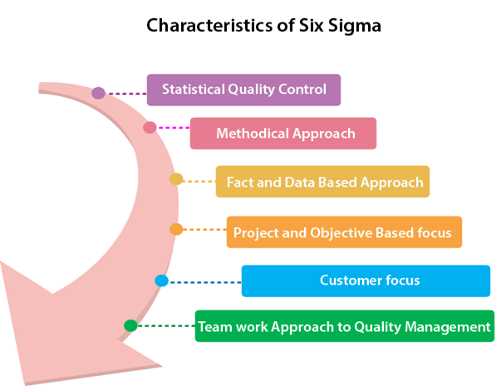
- Statistical Quality Control: Six Sigma is derived from the Greek Letter σ (Sigma) from the Greek alphabet, which is used to denote Standard Deviation in statistics. Standard Deviation is used to measure variance, which is an essential tool for measuring non-conformance as far as the quality of output is concerned.
- Methodical Approach: The Six Sigma is not a merely quality improvement strategy in theory, as it features a well defined systematic approach of application in DMAIC and DMADV which can be used to improve the quality of production. DMAIC is an acronym for Design-Measure- Analyze-Improve-Control. The alternative method DMADV stands for Design-Measure- Analyze-Design-Verify.
- Fact and Data-Based Approach: The statistical and methodical aspect of Six Sigma shows the scientific basis of the technique. This accentuates essential elements of the Six Sigma that is a fact and data-based.
- Project and Objective-Based Focus: The Six Sigma process is implemented for an organization's project tailored to its specification and requirements. The process is flexed to suits the requirements and conditions in which the projects are operating to get the best results.
- Customer Focus: The customer focus is fundamental to the Six Sigma approach. The quality improvement and control standards are based on specific customer requirements.
- Teamwork Approach to Quality Management: The Six Sigma process requires organizations to get organized when it comes to controlling and improving quality. Six Sigma involving a lot of training depending on the role of an individual in the Quality Management team.

Six Sigma Methodologies
Six Sigma projects follow two project methodologies:
- DMAIC
- DMADV

DMAIC
It specifies a data-driven quality strategy for improving processes. This methodology is used to enhance an existing business process.
The DMAIC project methodology has five phases:
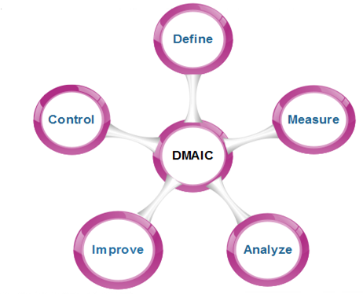
- Define: It covers the process mapping and flow-charting, project charter development, problem-solving tools, and so-called 7-M tools.
- Measure: It includes the principles of measurement, continuous and discrete data, and scales of measurement, an overview of the principle of variations and repeatability and reproducibility (RR) studies for continuous and discrete data.
- Analyze: It covers establishing a process baseline, how to determine process improvement goals, knowledge discovery, including descriptive and exploratory data analysis and data mining tools, the basic principle of Statistical Process Control (SPC), specialized control charts, process capability analysis, correlation and regression analysis, analysis of categorical data, and non-parametric statistical methods.
- Improve: It covers project management, risk assessment, process simulation, and design of experiments (DOE), robust design concepts, and process optimization.
- Control: It covers process control planning, using SPC for operational control and PRE-Control.

DMADV
It specifies a data-driven quality strategy for designing products and processes. This method is used to create new product designs or process designs in such a way that it results in a more predictable, mature, and detect free performance.
The DMADV project methodology has five phases:
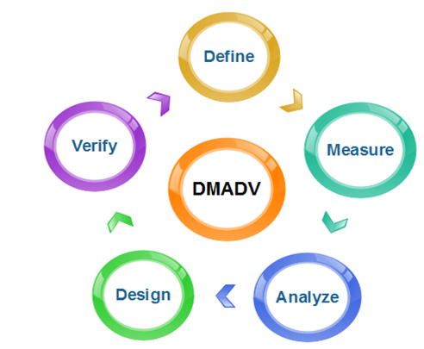
- Define: It defines the problem or project goal that needs to be addressed.
- Measure: It measures and determines the customer's needs and specifications.
- Analyze: It analyzes the process to meet customer needs.
- Design: It can design a process that will meet customer needs.
- Verify: It can verify the design performance and ability to meet customer needs.

Capability Maturity Model Integration (CMMI)
Capability Maturity Model Integration (CMMI) is a successor of CMM and is a more evolved model that incorporates best components of individual disciplines of CMM like Software CMM, Systems Engineering CMM, People CMM, etc. Since CMM is a reference model of matured practices in a specific discipline, so it becomes difficult to integrate these disciplines as per the requirements. This is why CMMI is used as it allows the integration of multiple disciplines as and when needed.
Objectives of CMMI :
- Fulfilling customer needs and expectations.
- Value creation for investors/stockholders.
- Market growth is increased.
- Improved quality of products and services.
- Enhanced reputation in Industry.
CMMI Representation – Staged and Continuous :
A representation allows an organization to pursue a different set of improvement objectives. There are two representations for CMMI :
- Staged Representation :
  - uses a pre-defined set of process areas to define improvement path.

  - provides a sequence of improvements, where each part in the sequence serves as a foundation for the next.

  - an improved path is defined by maturity level.
  - maturity level describes the maturity of processes in organization.
  - Staged CMMI representation allows comparison between different organizations for multiple maturity levels.
- Continuous Representation :
  - allows selection of specific process areas.
  - uses capability levels that measures improvement of an individual process area.
  - Continuous CMMI representation allows comparison between different organizations on a process-area-by-process-area basis.
  - allows organizations to select processes which require more improvement.
  - In this representation, order of improvement of various processes can be selected which allows the organizations to meet their objectives and eliminate risks.
CMMI Model – Maturity Levels :
In CMMI with staged representation, there are five maturity levels described as follows :
- Maturity level 1 : Initial
  - processes are poorly managed or controlled.
  - unpredictable outcomes of processes involved.
  - ad hoc and chaotic approach used.
  - No KPAs (Key Process Areas) defined.
  - Lowest quality and highest risk.
- Maturity level 2 : Managed
  - requirements are managed.
  - processes are planned and controlled.
  - projects are managed and implemented according to their documented plans.
  - This risk involved is lower than Initial level, but still exists.
  - Quality is better than Initial level.
- Maturity level 3 : Defined
  - processes are well characterized and described using standards, proper procedures, and methods, tools, etc.
  - Medium quality and medium risk involved.
  - Focus is process standardization.
- Maturity level 4 : Quantitatively managed
  - quantitative objectives for process performance and quality are set.
  - quantitative objectives are based on customer requirements, organization needs, etc.
  - process performance measures are analyzed quantitatively.
  - higher quality of processes is achieved.
  - lower risk
- Maturity level 5 : Optimizing
  - continuous improvement in processes and their performance.
  - improvement has to be both incremental and innovative.
  - highest quality of processes.
  - lowest risk in processes and their performance.
CMMI Model – Capability Levels
A capability level includes relevant specific and generic practices for a specific process area that can improve the organization’s processes associated with that process area. For CMMI models with continuous representation, there are six capability levels as described below :
- Capability level 0 : Incomplete
  - incomplete process – partially or not performed.
  - one or more specific goals of process area are not met.
  - No generic goals are specified for this level.
  - this capability level is same as maturity level 1.
- Capability level 1 : Performed
  - process performance may not be stable.
  - objectives of quality, cost and schedule may not be met.
  - a capability level 1 process is expected to perform all specific and generic practices for this level.
  - only a start-step for process improvement.
- Capability level 2 : Managed
  - process is planned, monitored and controlled.
  - managing the process by ensuring that objectives are achieved.
  - objectives are both model and other including cost, quality, schedule.
  - actively managing processing with the help of metrics.
- Capability level 3 : Defined
  - a defined process is managed and meets the organization’s set of guidelines and standards.
  - focus is process standardization.
- Capability level 4 : Quantitatively Managed
  - process is controlled using statistical and quantitative techniques.
  - process performance and quality is understood in statistical terms and metrics.
  - quantitative objectives for process quality and performance are established.
- Capability level 5 : Optimizing
  - focuses on continually improving process performance.
  - performance is improved in both ways – incremental and innovation.
  - emphasizes on studying the performance results across the organization to ensure that common causes or issues are identified and fixed.

CMMI Key Process Areas
A Process Area is a cluster of related practices in an area that, when implemented collectively, satisfy a set of goals considered important for making significant improvement in that area. All CMMI process areas are common to both continuous and staged representations.
The continuous representation enables the organization to choose the focus of its process improvement efforts by choosing those process areas, or sets of interrelated process areas, that best benefit the organization and its business objectives. Although there are some limits on what an organization can choose because of the dependencies among process areas, the organization has considerable freedom in its selection.
Once you select the process areas, you must also select how much you would like to improve the processes associated with those process areas (i.e., select the appropriate capability level). Capability levels and generic goals and practices support the improvement of processes in individual process areas.
Conversely, you will see that the staged representation encourages you to always look at process areas in the context of the maturity level to which they belong. The process areas are organized by maturity levels to reinforce this concept. When you use a process area, you use the entire process area: all goals and all practices.
The CMMI Process Areas (PAs) can be grouped into the following four categories to understand their interactions and links with one another regardless of their defined level:

- Process Management
- Project Management
- Engineering
- Support

Each process area is defined by a set of goals and practices. There are two categories of goals and practices:

Generic goals and practices: They are part of every process area.

Specific goals and practices: They are specific to a given process area.

A process area is satisfied when company processes cover all of the generic and specific goals and practices for that process area.

Generic goals and practices:
Generic goals and practices are a part of every process area.
NOTATIONS:GG --> Generic Goals and GP --> Generic Practice

GG 1 Achieve Specific Goals

GP 1.1 Perform Specific Practices

GG 2 Institutionalise a Managed Process

GP 2.1 Establish an Organizational Policy

GP 2.2 Plan the Process

GP 2.3 Provide Resources

GP 2.4 Assign Responsibility

GP 2.5 Train People

GP 2.6 Manage Configurations

GP 2.7 Identify and Involve Relevant Stakeholders

GP 2.8 Monitor and Control the Process

GP 2.9 Objectively Evaluate Adherence

GP 2.10 Review Status with Higher Level Management

GG 3 Institutionalise a Defined Process

GP 3.1 Establish a Defined Process

GP 3.2 Collect Improvement Information

GG 4 Institutionalise a Quantitatively Managed Process

GP 4.1 Establish Quantitative Objectives for the Process

GP 4.2 Stabilise Subprocess Performance

GG 5 Institutionalise an Optimising Process

GP 5.1 Ensure Continuous Process Improvement

GP 5.2 Correct Root Causes of Problems

Common Features:
The common features are attributes that indicate whether the implementation and institutionalization of a key process area is effective, repeatable, and lasting. The five common features are listed below:

Commitment to Perform: Commitment to Perform describes the actions the organization must take to ensure that the process is established and will endure. Commitment to Perform typically involves establishing organizational policies and senior management sponsorship.

Ability to Perform: Ability to Perform describes the preconditions that must exist in the project or organization to implement the software process competently. Ability to Perform typically involves resources, organizational structures, and training.

Activities Performed: Activities Performed describes the roles and procedures necessary to implement a key process area. Activities Performed typically involve establishing plans and procedures, performing the work, tracking it, and taking corrective actions as necessary.

Measurement and Analysis: Measurement and Analysis describes the need to measure the process and analyze the measurements. Measurement and Analysis typically includes examples of the measurements that could be taken to determine the status and effectiveness of the Activities Performed.

Verifying Implementation: Verifying Implementation describes the steps to ensure that the activities are performed in compliance with the process that has been established. Verification typically encompasses reviews and audits by management and software quality assurance.

The practices in the common feature Activities Performed describe what must be implemented to establish a process capability. The other practices, taken as a whole, form the basis by which an organization can institutionalize the practices described in the Activities Performed common feature.

McCall’s Quality Factors
McCall software quality model was introduced in 1977. This model is incorporated with many attributes, termed as software factors, which influence a software. The model distinguishes between two levels of quality attributes :
- Quality Factors –
The higher level quality attributes which can be assessed directly are called quality factors. These attributes are external attributes.The attributes in this level are given more importance by the users and managers.
- Quality Criteria –
The lower or second level quality attributes which can be assessed either subjectively or objectively are called Quality Criteria. These attributes are internal attributes. Each quality factor has many second level of quality attributes or quality criteria.

Example –
Usability quality factor is divided into operability, training, communicativeness, input/output volume, input/output rate. This model classifies all software requirements into 11 software quality factors. The 11 factors are organised into three product quality factors – product operation, product revision, and product transition factors.

The following are the product quality factors –

1. Product Operation :
It includes five software quality factors, which are related with the requirements that directly affect the operation of the software such as operational performance, convenience, ease of usage and its correctness. These factors help in providing a better user experience.

  - Correctness –
The extent to which a software meets its requirements specification.
  - Efficiency –
The amount of hardware resources and code the software, needs to perform a function.
  - Integrity –
The extent to which the software can control an unauthorized person from the accessing the data or software.
  - Reliability –
The extent to which a software performs its intended functions without failure.
  - Usability –
The extent of effort required to learn, operate and understand the functions of the software.

2. Product Revision :
It includes three software quality factors, which are required for testing and maintenance of the software. They provide ease of maintenance, flexibility and testing effort to support the software to be functional according to the needs and requirements of the user in the future.
  - Maintainability –
The effort required to detect and correct an error during maintenance phase.
  - Flexibility –
The effort needed to improve an operational software program.
  - Testability –
The effort required to verify a software to ensure that it meets the specified requirements.

3. Product Adaptation :
It includes three software quality factors, that allows the software to adapt to the change of environments in the new platform or technology from the previous.
  - Portability –
The effort required to transfer a program from one platform to another.
  - Re-usability –
The extent to which the program’s code can be reused in other applications.
  - Interoperability –
The effort required to integrate two systems with one another.
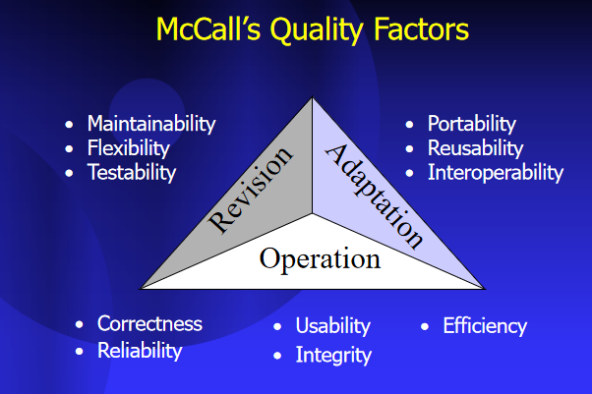

Efficiency and integrity are two key quality factors in the context of software engineering and systems development:

1. **Efficiency**:
- **Definition**: Efficiency refers to the ability of a system to perform its functions quickly and with minimal resource consumption, such as time, memory, or processing power.
- **Importance**: Efficient systems are able to accomplish tasks in a timely manner and utilize resources effectively, resulting in optimal performance and user satisfaction.
- **Metrics**: Efficiency can be measured using metrics such as response time, throughput, scalability, and resource utilization.
- **Considerations**: Designing for efficiency involves optimizing algorithms, data structures, and system architecture to minimize overhead and maximize performance. It also requires balancing trade-offs between speed, resource usage, and other system attributes.

2. **Integrity**:
- **Definition**: Integrity refers to the accuracy, consistency, and reliability of data and operations within a system.
- **Importance**: Systems with high integrity ensure that data remains accurate and consistent throughout its lifecycle, preventing errors, corruption, or unauthorized access.
- **Metrics**: Integrity can be assessed through metrics such as data validation, error detection and correction mechanisms, audit trails, and security controls.
- **Considerations**: Ensuring integrity involves implementing mechanisms to validate and authenticate data, enforce data integrity constraints, and protect against unauthorized modifications or access. It also involves designing robust error handling and recovery mechanisms to detect and mitigate data corruption or loss.

In summary, efficiency focuses on optimizing system performance and resource utilization, while integrity emphasizes the accuracy, consistency, and reliability of data and operations within a system. Both factors are critical for designing and building high-quality software systems that meet the needs of users and stakeholders.

ISO 9000 Quality Standards :
It is defined as the quality assurance system in which quality components can be organizational structure, responsibilities, procedures, processes, and resources for implementing quality management. Quality assurance systems are created to help organizations ensure their products and services satisfy customer expectations by meeting their specifications.
ISO (International Standards Organization) is a group or consortium of 63 countries established to plan and fosters standardization. ISO declared its 9000 series of standards in 1987. It serves as a reference for the contract between independent parties. The ISO 9000 standard determines the guidelines for maintaining a quality system. The ISO standard mainly addresses operational methods and organizational methods such as responsibilities, reporting, etc. ISO 9000 defines a set of guidelines for the production process and is not directly concerned about the product itself.
The ISO 9000 series of standards is based on the assumption that if a proper stage is followed for production, then good quality products are bound to follow automatically. The types of industries to which the various ISO standards apply are as follows.
ISO 9001: This standard applies to the organizations engaged in design, development, production, and servicing of goods. This is the standard that applies to most software development organizations.
ISO 9002: This standard applies to those organizations which do not design products but are only involved in the production. Examples of these category industries contain steel and car manufacturing industries that buy the product and plants designs from external sources and are engaged in only manufacturing those products. Therefore, ISO 9002 does not apply to software development organizations.
ISO 9003: This standard applies to organizations that are involved only in the installation and testing of the products. For example, Gas companies.

Different types of ISO standards :
Here, you will see different types of ISO standards as follows.
- ISO 9000: 2000 –
ISO 9000: 2000: contains Quality management systems, fundamentals, and vocabulary.
- ISO 9000-1: 1994 –
This series of standards includes Quality management systems and Quality assurance standards. It also includes some guidelines for selection and use.
- ISO 9000-2: 1997 –
- This series of standards also includes Quality management systems and Quality assurance standards. It also includes some guidelines for the application of ISO 9001, ISO 9002, and ISO 9003.
- ISO 9000-3: 1997 –
This series contains Quality management systems, Quality assurance standards and also includes guidelines for the application of ISO 9001 to 1994 to the development, supply, installation, and maintenance of computer installation.
- ISO 9001: 1994 –
This series of standards has Quality systems and a Quality assurance model. This model helps in design, development, production, installation, and service.
- ISO 9001: 2000 –
This series of standards also includes Quality management systems.
- ISO 9002: 1994 –
This series of standards also includes some Quality systems. This Quality assurance model used in production, installation, and servicing.
- ISO 9003: 1994 –
This series of standards also includes some Quality systems. This Quality assurance model used in the final inspection and test.
- ISO 9004: 2000 –
This series of standards include some Quality management systems. It also includes some guidelines for performance improvements.
- ISO 9039: 1994 –
This series of standards include some Optics and Optical Instruments. It includes quality evaluation of optical systems and determination of distortion.
- ISO/IEC 9126-1: 2001 –
This series of standards has information technology. It also includes some software products, quality models.
- ISO/IEC 9040: 1997 –
This series of standards has information technology. It also includes open system interconnection and Virtual terminal basic class service.
- ISO/IEC 9041-1: 1997 –
This series of standards has information technology. It also includes open system interconnection, Virtual terminal basic class service protocol, and specification.
- ISO/IEC 9041-2: 1997 –
This series of standards include information technology, open system interconnection, Virtual terminal basic class protocol, and Protocol implementation conformance statement (PICS) proforma.
- ISO/IEC 9075-9: 2001 –
This series of standards has information technology, Database languages, and SQL/MED(Management of External Data).
- ISO/IEC 9075-10: 2000 -|
This series of standards has information technology, Database languages, and SQL/OLB (Object Language Bindings).
- ISO/IEC 9075-13: 2002 –
This series of standards has information technology, Database languages, SQL routines, and Java Programming language. (SQL/JRT).

ISO 9000 is a set of international standards for quality management systems (QMS) developed by the International Organization for Standardization (ISO). The ISO 9000 family of standards provides guidelines and requirements for organizations to implement and maintain effective quality management practices, ensuring consistency in product and service delivery, customer satisfaction, and continuous improvement.

To obtain certification under the ISO 9000 standards, organizations typically follow these steps:

1. **Understand ISO 9000 Requirements**: Familiarize yourself with the ISO 9000 standards and their requirements. You can access the standards directly from the ISO website or through national standards bodies.

2. **Assess Current Processes**: Evaluate your organization's existing quality management practices against the requirements of the ISO 9000 standards. Identify gaps and areas for improvement.

3. **Develop a Quality Management System**: Develop and document a quality management system (QMS) that meets the requirements of the ISO 9000 standards. This may involve defining quality policies, procedures, processes, and performance metrics.

4. **Implement QMS**: Implement the QMS across the organization, ensuring that all relevant personnel are trained and aware of their roles and responsibilities in maintaining quality standards.

5. **Internal Audit**: Conduct internal audits to assess the effectiveness of the QMS and identify any non-conformities or areas for improvement.

6. **Corrective Actions**: Take corrective actions to address any non-conformities identified during internal audits, ensuring that root causes are identified and addressed effectively.

7. **Management Review**: Conduct periodic management reviews of the QMS to ensure its ongoing suitability, adequacy, and effectiveness.

8. **Select Certification Body**: Choose an accredited certification body to conduct an external audit of your QMS and assess compliance with the ISO 9000 standards.

9. **External Audit**: The certification body will conduct an external audit of your organization's QMS to verify compliance with the ISO 9000 standards. This may involve document reviews, interviews, and on-site inspections.

10. **Certification**: If your organization's QMS meets the requirements of the ISO 9000 standards, the certification body will issue an ISO 9000 certificate, indicating compliance with the standards.

11. **Maintain Certification**: Maintain ongoing compliance with the ISO 9000 standards by continually monitoring and improving your QMS, conducting regular internal audits, and participating in periodic surveillance audits conducted by the certification body.

It's important to note that while certification to ISO 9000 standards demonstrates an organization's commitment to quality management, it does not guarantee the quality of products or services. Certification is an ongoing process that requires continuous improvement and commitment to quality principles.

SOFTWARE SECURITY
INTRODUCTION TO DevOps

DevOps is the acronym given to the combination of Development and Operations. It refers to a collaborative approach to make the Application Development team and the IT Operations team of an organization to seamlessly work with better communication. It is a philosophy that encourages adopting iterative software development, automation, and programmable infrastructure deployment and maintenance.
DevOps emphasizes building trust and better liasioning between developers and system administrators. This helps the organization in aligning technological projects to business requirements. Changes rolled out are usually small and reversible, which the entire team begins to comprehend.
DevOps is visualized as an infinite loop comprising the steps: plan, code, build, test, release, deploy, operate, monitor, then back to plan, and so on.

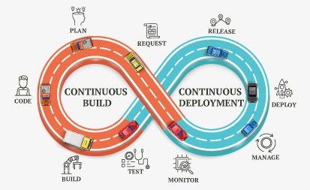

- BUILD AUTOMATION – An automated code is prepared to be deployed in a live environment where the tool used is tied to the programming language chosen. This makes the whole process faster, consistent and more repeatable. Further, it also ensures that your process is more reliable than any manual build.
- CI/ CD – Continuous Integration and Continuous Deployment deals with frequent merging of codes and unit testing. Further, the deployment of small code changes in a routine and frequent process is also a part of this method. CI/CD helps massively as it helps you detect bugs early and maintains the use of modular code with minimal effort. It also reduces the time to market and introduces reliable rollbacks.
- INFRASTRUCTURE AS CODE – This is usually to manage and provision IT infrastructure through code and automation. This is reusable, and helps in consistent resource creation and management. Furthermore, the infrastructure is self-documenting and simplifies complex material like authentication and application servers.
- CONFIGURATION MANAGEMENT – This is the process where you can manage and change the state of infrastructure in constant and maintainable ways. This way, you end up saving a lot of time while also minimizing configuration drift, especially in large server environments. Configuration Management also helps provide insight documentation on infrastructure.
- ORCHESTRATION – Orchestration is nothing but an automation that supports processes and workflows, like Resource Planning. It not only helps you save time, but you also achieve stability, especially with an automatic response to detection of various problems.
- MONITORING – By this method, you collect and present data about the performance and stability of services and infrastructure, while also detecting problems. This enables faster recovery, helps with cross-team visibility, provides more data to analyze for better root-cause analysis and also generates an automated response.
- MICROSERVICES – It is basically an architecture that breaks an application into many small and loosely collected services. This way, you end up reducing complexity and increase flexibility in choice of technology.
Methodologies, Principles and Strategies
While DevOps is seen as a natural extension of Agile, and somewhat of an anathema for ITIL, it does not have its own framework – and can potentially be relevant for a variety of situations.
Organizations that use traditional (waterfall) methods, characterized by sequential stages of software development and long gaps between software releases, can use DevOps principles for better alignment between functions such as Dev, QA, and Operations, with a greater transparency into all functions. Organizations that have adopted one or more Agile methodologies can easily have their dev and operations folks collaborate throughout the development process.
Newer disciplines such as AIOps, SRE (Site Reliability Engineering), SysOps, DevSecOps and BizDevOps extend and expand DevOps principles and benefits while adding other critical technology and methodologies such as AI, automation, security and collaboration to further the cause of high quality agile software development.

The Lifecycle of DevOps :
Below is the diagram which indicates the structure of the DevOps lifecycle.
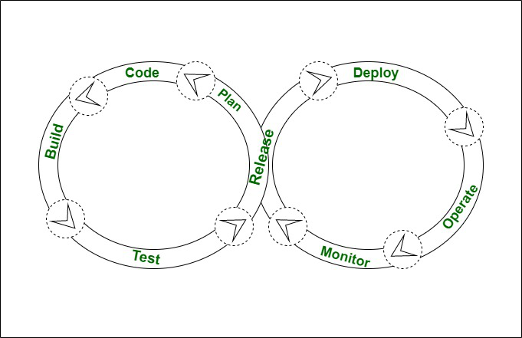
- Code –
Coding is the first step in the development of DevOps. In this step, the developers and coders write the code on any platform to develop the product for a customer.
- Build –
The 2nd step is to construct the model, in which the simple model of the product has constructed the use of an appropriate programming language.
- Test –
The third step is to test or to check where the constructed merchandise and other products are going to examine with the use of the automation checking out equipment such as Bugzilla and selenium web driver.
- Release –
This step includes planning, scheduling and controlling the constructed method in a one of a kind environment.
- Deploy –
The step after the release phase will be Deployment where all the products, files and documents which are to deployed are carried out on the server.
- Operate –
After the deployment phase i.e. after the deployment of the product or application, it is delivered to the client for use where he makes use of that product or software for everyday lifestyles purposes.
- Monitor –
In this step, the delivered merchandise or software to a client has been monitored to observe down any up-time and down-time failures or if any errors are there or not.
- Plan –
The last phase is Planning. After monitoring it gathers all the information, data, feedback and comments from the client and plans the modifications that need to be performed to make it better.

Software Security
In the general sense, security is “the state of being free from danger or threat”. The security of software systems in particular is a vast topic.
Software security is the application of techniques that assess, mitigate, and protect software systems from vulnerabilities. These techniques ensure that software continues to function and are safe from attacks. Developing secure software involves considering security at every stage of the life cycle. The major goal is to identify flaws and defects as early as possible.

Software Security Techniques
Applying software security techniques to software development produces higher levels of quality² Safer software has correct and predictable behavior.
- Code review using tools to find bugs, vulnerabilities, and weaknesses
- Architectural risk analysis to identify flaws
- Penetration testing
- Risk-based security testing
- Abuse cases to examine how a system behaves under attack
- Security requirements
- Security operations
Many techniques can be applied in this type of framework, such as:
- Defensive programming
- Secure coding
- Threat modeling (e.g., STRIDE)
- Understanding your attack surface
- Sandboxing
- Code auditing
- Application security (e.g., OWASP Top Ten)
- Defense in depth

DevSecOps
DevSecOps is the deep integration of security into the DevOps approach. It enables security teams and developers to “shift left” by automating analysis of software security earlier and throughout the software development lifecycle.
DevSecOps introduces security to the DevOps practices used for developers and IT operations. Security controls are embedded in processes such as build pipelines and CI/CD workflows. These practices provide immediate feedback cycles. In this mindset, security is everyone’s responsibility.

Security Testing
Automated security testing and security analysis techniques are part of DevSecOps. These include Static Application Security Testing (SAST) and Dynamic Application Security Testing (DAST). SAST tools analyze the source code of an application before it compiles. DAST tools communicate with the running application to identify security vulnerabilities.
It is best practice to run security testing tools continuously. Traditional processes focus on security testing before a big release. The collective security mindset in the defense industry is shifting left. DevSecOps adoption is growing, enabling continuous security to become a reality.

